  International School of Pristine |  | CLASS 5A |  |  |  |  |  |  | Class Teacher:   Hüseyin Sekmenoğlu
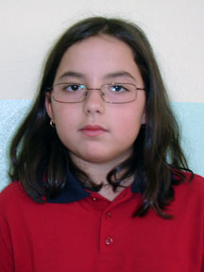 | 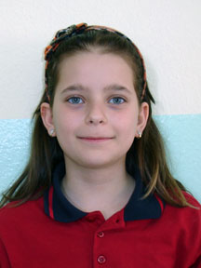
Rrona Dushi | Beyzanur Boyuker |  |  |  |  |  |  |  | Captain: 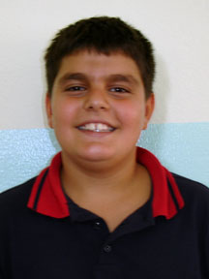  Gent Smajlaj
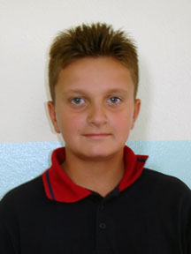 | 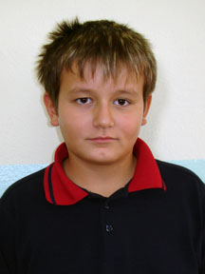 |  | 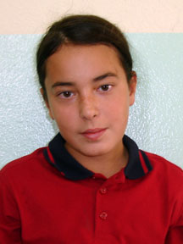 | 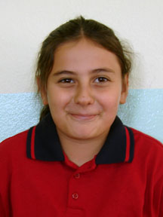 |  | 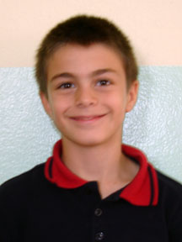 | 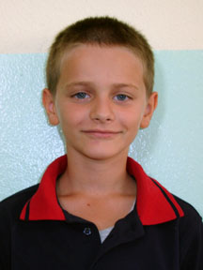
Erdi Kryeziu | Fiton Jusaj |  | Nesa Kazagiqi | Ümran Betül Şen |  | Mesud Cengiz | Drin Grapci
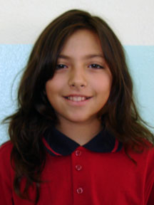 | 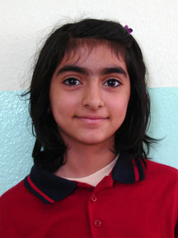 |  |  | 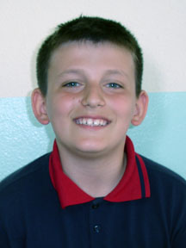 |  | 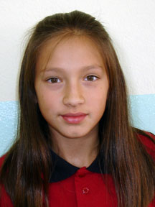 | 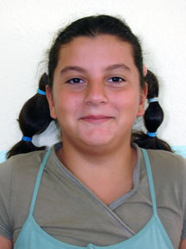 |  | Vice Captain:  Bulza Bajrami
Erisa Ismajli | Ayşe Günakan |  | Gent Smajlaj | Berat Mirashi |  | Bulza Bajrami | Edanur Abacı

